# Pizza Ordering System

# Group Details:-

1. **Group Details:-**

* **Members:**
* 54 – Krina Shah
* 55 – Nidhi Shah
* **Programme :**
* iMCA
* **Semester:**
* 4th Semester – SYiMCA
* **Project Title:**
* Pizza Ordering System
* **Course:**
* ADMBS

1. **Project Description:-**

You must have ordered your pizzas on phone for home delivery. The process seems easy to use but at times there is miscommunication. As there is no visual menu shown during a phone call, the employees have to repeat a lot of things again and again to the customers. It's a time consuming process which at times irritates customers. Also it takes a lot of time of the pizzeria staff. It would be much more comfortable for the customers to have an online pizza ordering system. It would be hassle free for users as they can select the pi772C they want and make payment for it. Also it will reduce the purchasing time for customers. Let us look at another benefit of using this system. Suppose I go to a pizzeria and make order. Even after ordering pizzas from their outlet, I have to wait at least 15 minutes for my order to be ready. Wouldn't it be much more convenient if I ordered my Pizzas before using a mobile app or an online system and then it will tell me the time by which I have to pick my order from their counter. It would be great for me as I don't need to wait for my pizza. I need to reach there only when my pizza is ready. In a nutshell, we can say that improved and efficient services are provided to the customers by the inclusion of internet in your business. As a business point of view it gives you an edge over your competitors.

**3. System Requirement Specification:-**

**1) Introduction:**

• Purpose

• System has features which attract users

**2) Overall Description:**

• Anyone can access it from anywhere

• Site would be made in PHP and overall database in SQL.

• Admin can generate menu, add pizza, edit pizza and delete pizza.

• Customer can see menu, order pizza

**3) External Interface Requirements:**

• One admin has to log in into system to add / update / delete pizza.

**4) System Features:**

• There would be a process box which will load the form in the system

**5) Software Quality Attributes:**

• Characteristics – adaptability, availability, flexibility, correctness, interoperability, maintainability, portability, reliability, reusability, testability, usability.

**4. Entity-Relationship Model:-**

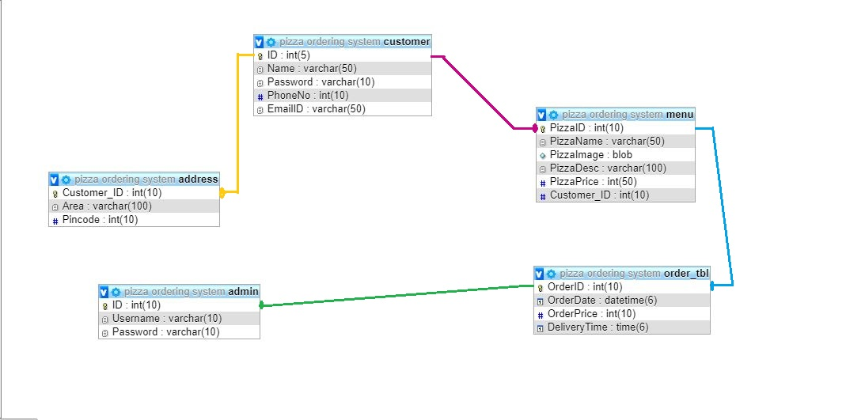

**Note**: We tried a lot to show relationships via Designer Tool in phpMyAdmin, but there was an error called “RELATIONSHIP ALREADY EXISTS.” So, we’ve shown them using Paint by your guidelines.

**5. Data Dictionary:-**

* **Admin**

|  |  |  |  |  |  |  |
| --- | --- | --- | --- | --- | --- | --- |
| **Column** | **Type** | **Null** | **Default** | **Links to** | **Comments** | **MIME** |
| ID  (Primary) | INT (10) | No |  |  |  |  |
| Username | VARCHAR (10) | No |  |  |  |  |
| Password | VARCHAR (10) | No |  |  |  |  |

**Indexes**

|  |  |  |  |  |  |  |  |  |
| --- | --- | --- | --- | --- | --- | --- | --- | --- |
| **Keyname** | **Type** | **Unique** | **Packed** | **Column** | **Cardinality** | **Collation** | **Null** | **Comment** |
| PRIMARY | BTREE | Yes | No | ID | 0 | A | No |  |

* **Customer**

|  |  |  |  |  |  |  |
| --- | --- | --- | --- | --- | --- | --- |
| **Column** | **Type** | **Null** | **Default** | **Links to** | **Comments** | **MIME** |
| ID  (Primary) | INT (5) | No |  |  |  |  |
| Name | VARCHAR(50) | No |  |  |  |  |
| Password | VARCHAR(10) | No |  |  |  |  |
| PhoneNo | INT(10) | No |  |  |  |  |
| EmailID | VARCHAR(50) | No |  |  |  |  |

* **Indexes**

|  |  |  |  |  |  |  |  |  |
| --- | --- | --- | --- | --- | --- | --- | --- | --- |
| **Keyname** | **Type** | **Unique** | **Packed** | **Column** | **Cardinality** | **Collation** | **Null** | **Comment** |
| PRIMARY | BTREE | Yes | No | ID | 4 | A | No |  |

* **Address**

|  |  |  |  |  |  |  |
| --- | --- | --- | --- | --- | --- | --- |
| **Column** | **Type** | **Null** | **Default** | **Links to** | **Comments** | **MIME** |
| Customer_ID  (Primary) | INT (10) | No |  |  |  |  |
| Area | VARCHAR(100) | No |  |  |  |  |
| Pincode | INT(10) | No |  |  |  |  |

* **Indexes**

|  |  |  |  |  |  |  |  |  |
| --- | --- | --- | --- | --- | --- | --- | --- | --- |
| **Keyname** | **Type** | **Unique** | **Packed** | **Column** | **Cardinality** | **Collation** | **Null** | **Comment** |
| PRIMARY | BTREE | Yes | No | Customer  _ID | 0 | A | No |  |

* **Menu**

|  |  |  |  |  |  |  |
| --- | --- | --- | --- | --- | --- | --- |
| **Column** | **Type** | **Null** | **Default** | **Links to** | **Comments** | **MIME** |
| PizzaID  (Primary) | INT(10) | No |  |  |  |  |
| Pizza_Name | VARCHAR(50) | No |  |  |  |  |
| Pizza_Image | BLOB | No |  |  |  |  |
| PizzaDesc | VARCHAR(100) | No |  |  |  |  |
| PizzaPrice | INT(50) | No |  |  |  |  |
| Customer_ID  (Primary) | INT (10) | No |  |  |  |  |

* **Indexes**

|  |  |  |  |  |  |  |  |  |
| --- | --- | --- | --- | --- | --- | --- | --- | --- |
| **Keyname** | **Type** | **Unique** | **Packed** | **Column** | **Cardinality** | **Collation** | **Null** | **Comment** |
| PRIMARY | BTREE | Yes | No | PizzaID | 2 | A | No |  |
| Customer_ID | BTREE | No | No | Customer  _ID | 2 | A | No |  |

* **Order_tbl**

|  |  |  |  |  |  |  |
| --- | --- | --- | --- | --- | --- | --- |
| **Column** | **Type** | **Null** | **Default** | **Links to** | **Comments** | **MIME** |
| OrderID  (Primary) | INT (10) | No |  |  |  |  |
| OrderDate | DATETIME(6) | No |  |  |  |  |
| OrderPrice | INT(10) | No |  |  |  |  |
| DelieveryTime | TIME(6) |  |  |  |  |  |

* **Indexes**

|  |  |  |  |  |  |  |  |  |
| --- | --- | --- | --- | --- | --- | --- | --- | --- |
| **Keyname** | **Type** | **Unique** | **Packed** | **Column** | **Cardinality** | **Collation** | **Null** | **Comment** |
| PRIMARY | BTREE | Yes | No | OrderID | 2 | A | No |  |

**6. Stored Procedure (With code to call procedure)**

**1. Find Customer Details**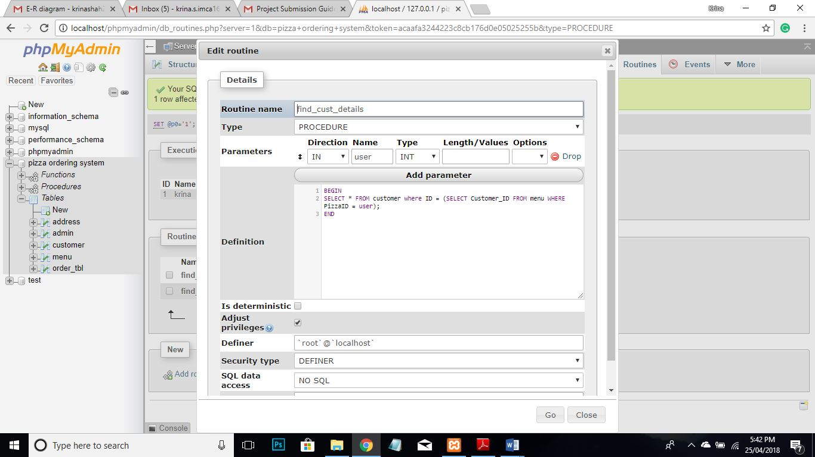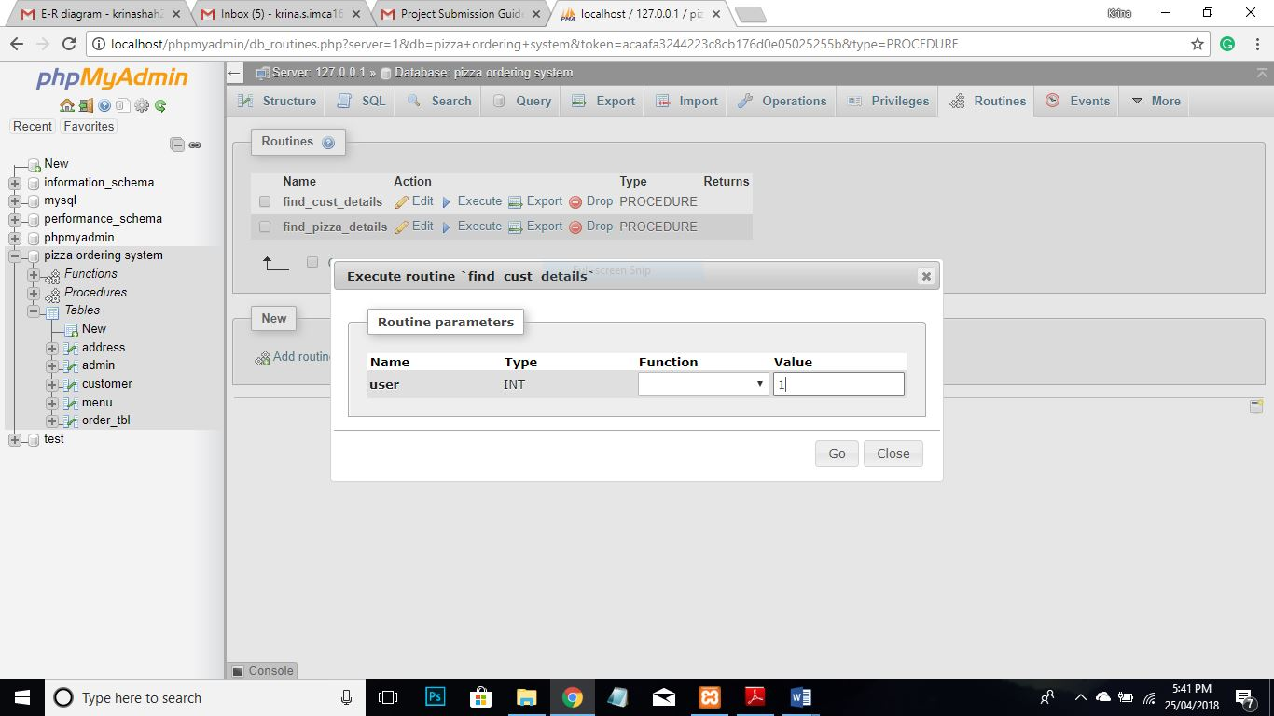

**OUTPUT**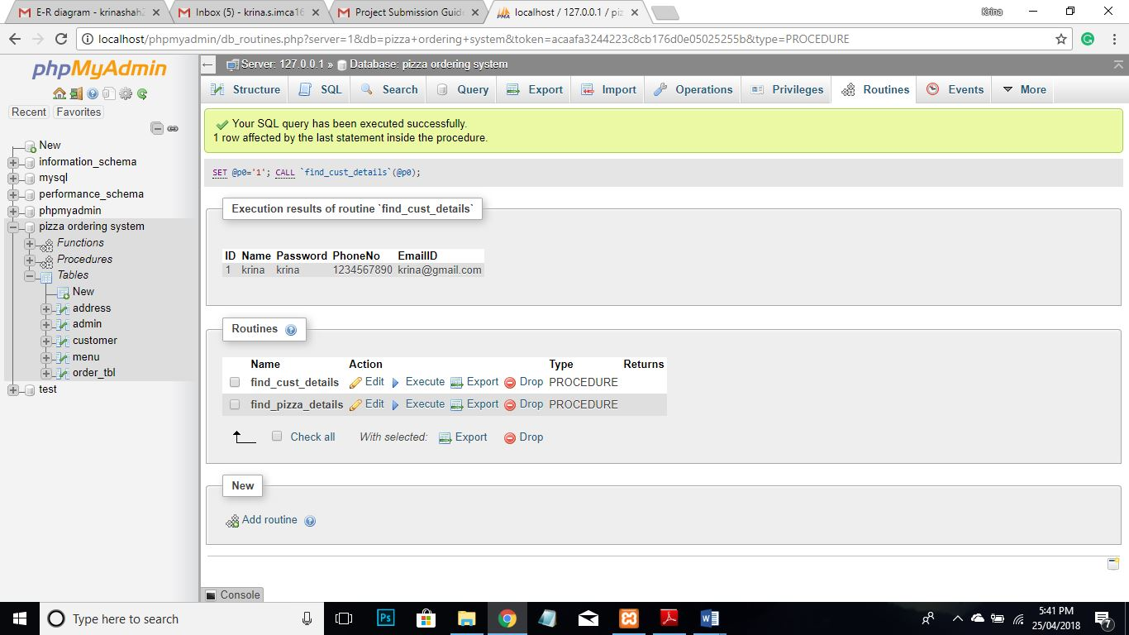

1. **Find Order Details**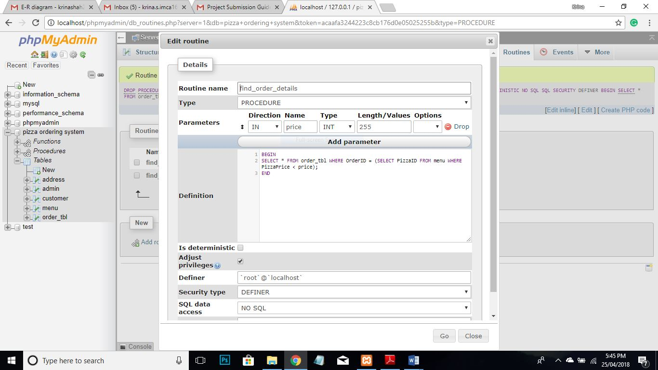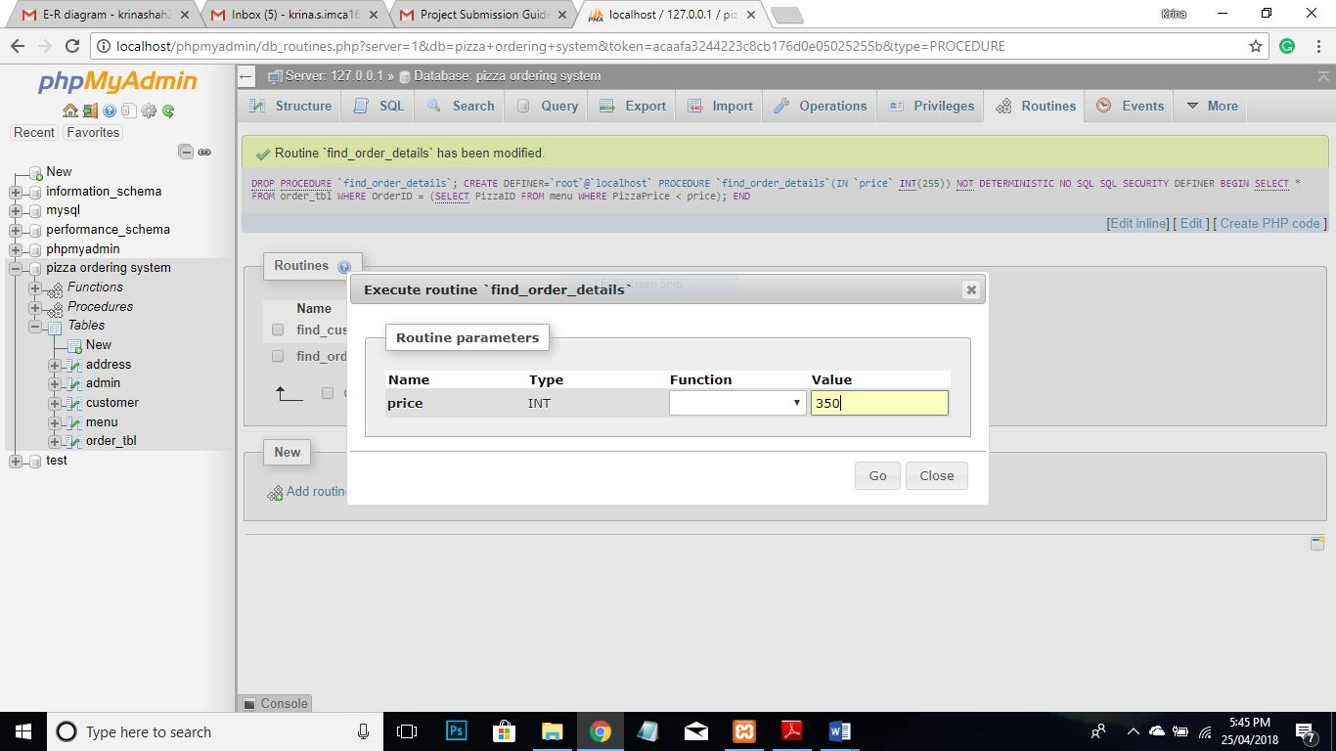

**Output:**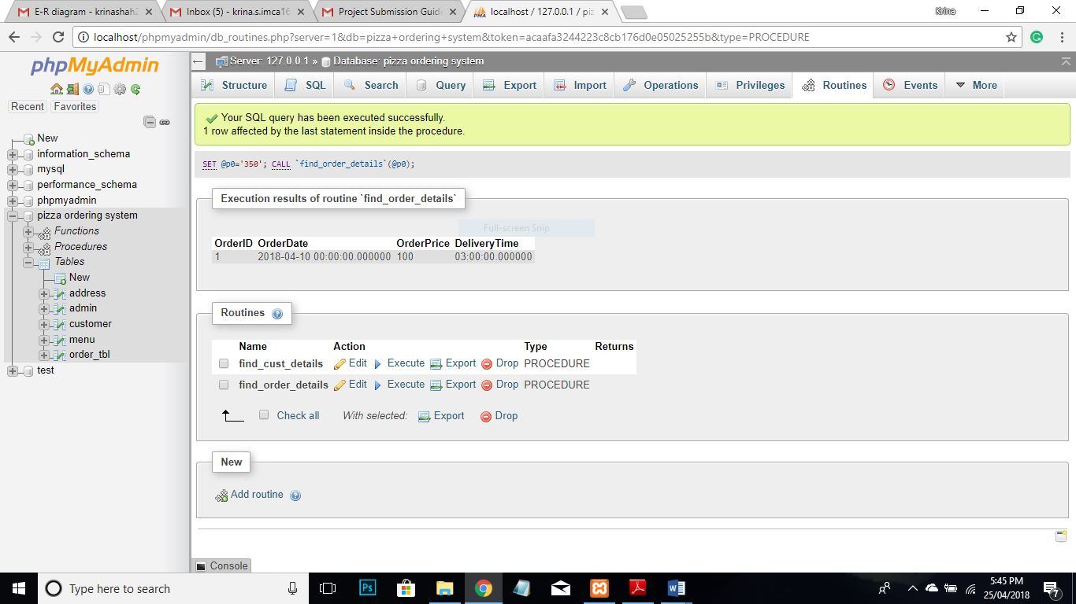

**7. Stored Function (With code to call Function)**

**Add new Customer**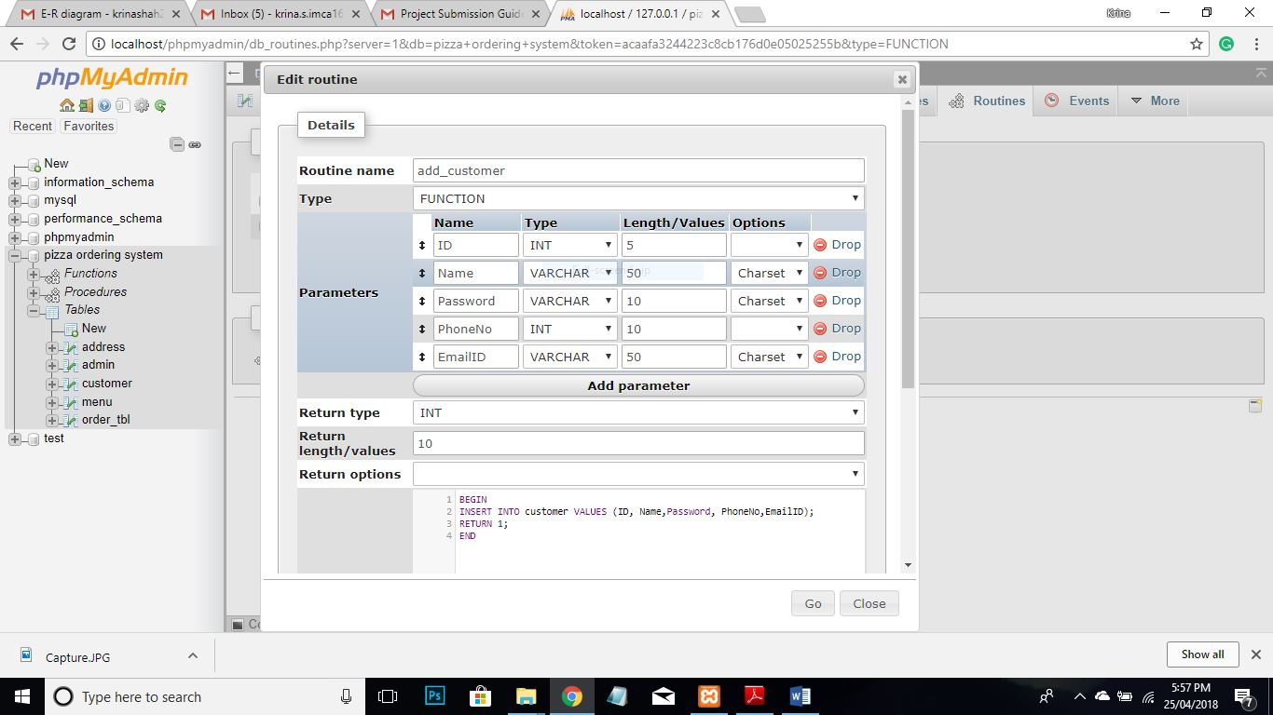

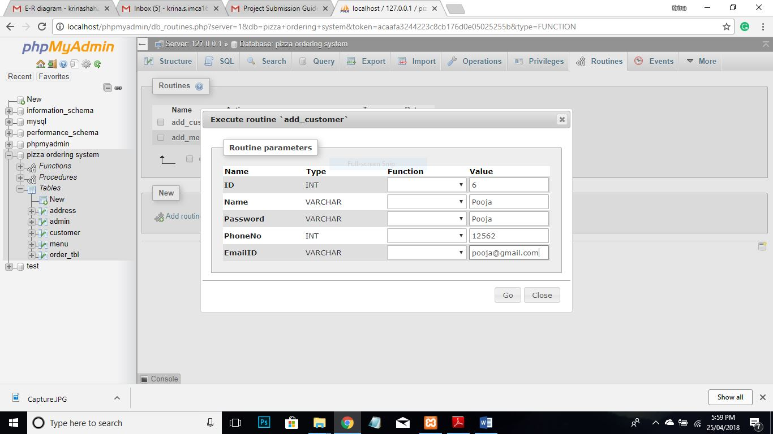

**Added customer (OUTPUT)**

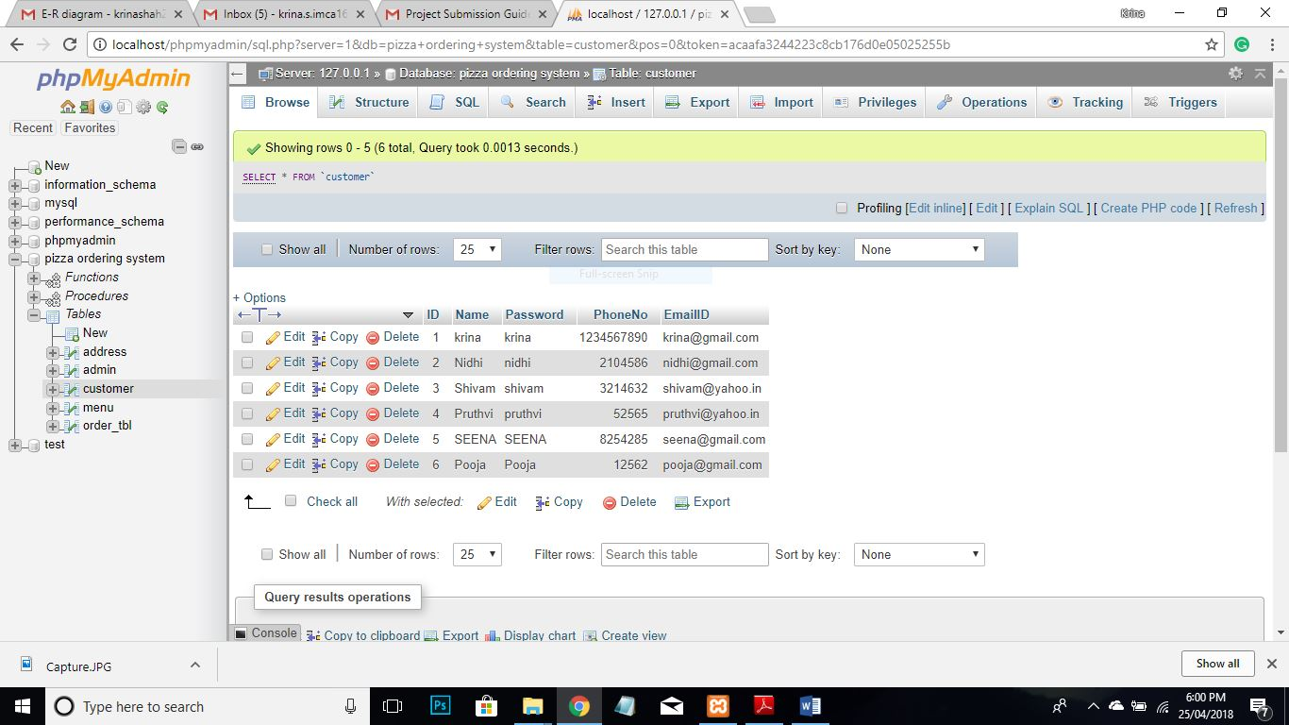

# **THANK YOU**